00000000000000000000000000000000000000000000000000000000000000000000000000000000000000000000000000000000000000000000000000

JC Rupe

Date: July 5**,** 2017

Version: 1.1



**Project Eden:**

*Authorize Resource Utilization and Blackout Dates*

**IT Project Management Office**

Document Revisions

|  |  |  |
| --- | --- | --- |
| Date | Version Number | Document Changes |
| 2017/04/07 | 1.0.0 JC | Document initial creation/completion. |
| 2017/07/05 | 1.1 JC | Rewrite document, due to major changes to the process. |
|  |  |  |
|  |  |  |
|  |  |  |
|  |  |  |
|  |  |  |
|  |  |  |
|  |  |  |

Contents

1 Resource Utilization (Move Coordinator) 3

1.1 Service Activity 3

1.1.1 Resources Requested for the Service Activity 3

1.1.2 The Current Utilization Table 4

1.1.3 The Get Override Button 4

1.2 View, Edit and Change Service Activity 5

1.2.1 Edit Current Resource Allocation and Utilization 5

1.2.2 View a Specific Date’s Current Resource Utilization 5

1.2.2.1 Save Resources for New Date 5

2 Utilization Threshold (Move Coordinator) 6

2.1 Utilization Reaches Exceeds 90% 6

2.2 Utilization Reaches or Exceeds 100% 6

3 Minimum Resource Check 7

4 Resource Blackout Dates (Move Coordinator) 7

4.1 Scheduled Start Date is on Blackout Date 7

5 Service Activity Creation Application (Move Coordinator) 8

6 Override Authorization (Dispatcher) 8

6.1 Authorize the Override 8

7 Set Blackout Dates (Dispatcher) 9

7.1 Set a Blackout Date 9

# Resource Utilization (Move Coordinator)

This section explains resource utilization and overrides. The Move Coordinator enters the desired resources and when the utilization threshold is exceeded, the Dispatcher must authorize an override.

## Service Activity

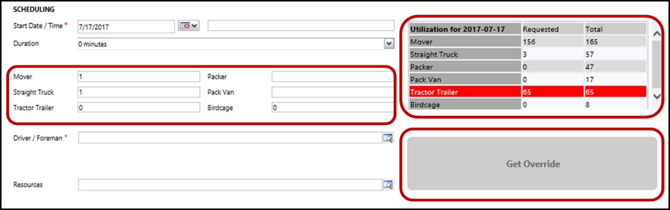

### Resources Requested for the Service Activity

* The Resources requested for the Service Activity are on the left of the Scheduling section. These represent how many of each resource is needed to perform the activity.

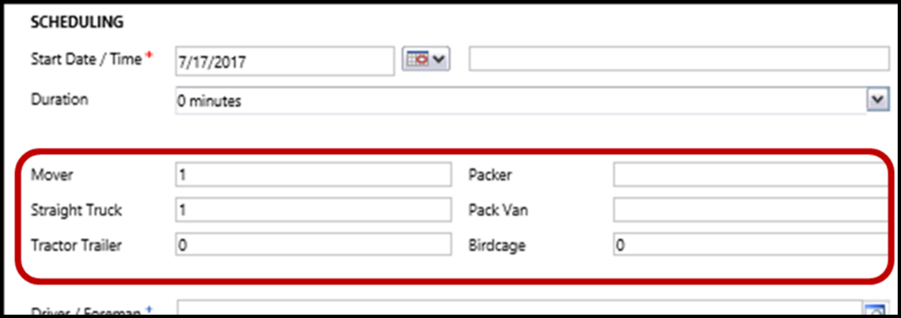

* Once the resource selections are saved, they **are** reflected in the Utilization table.
  + Note: When the resource selections are changed, the changes **aren’t** reflected in the Utilization table until they are successfully saved.

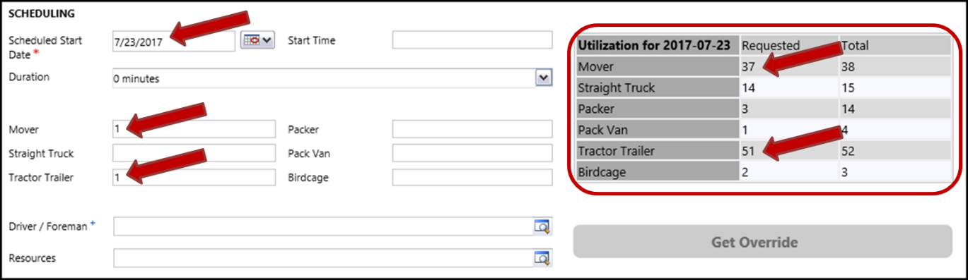

### The Current Utilization Table

* The Utilization table is displayed to the right of the requested resources. These represent resources for both JK Virginia and JK Maryland combined.
  + The date on the utilization table represents the **Scheduled Start Date** entered.
  + The first column contains that names of the Resources.
  + The **Total** column displays the total possible resources available that day. The number included allocated and unallocated resources.
  + The **Requested** column displays the number of resources that are already allocated to Service Activities, on that **Scheduled Start Date**.
    - Changes being made to the requested resources, for the current Service Activity and won’t be reflected here until the Service Activity is successfully saved.
    - **Note**: Once a Service Activity is successfully saved, its requested resources are then reflected in the **Requested** column.
    - **Note**: The resource highlighted in red is either at or over 100% utilization.
* The current Utilization table shows utilization information that combines both JK Virginia and JK Maryland resources.
* When a resources utilization is over 90%, the user will be prompted for Dispatcher override.
* When a resources utilization is 100% or more, the user will be prompted for Dispatcher override and (once saved) the resource line in the current Utilization table will be highlighted in red.
* For some Service Activities, a Minimum Resource Check is performed to ensure the proper resources are allocated.
* Utilization numbers are impacted only when:
  + The **Site** is “JK Virginia”
  + The **Site** is “JK Maryland”
  + The **Site** is “Off Terminal” and the Supplier is “JK Moving Services”

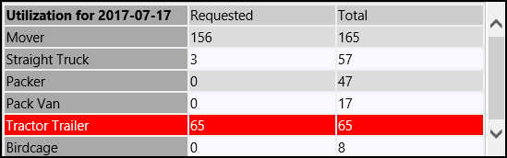

### The Get Override Button

* The “Get Override” button is located below the current Utilization table.
  + This button usually starts out grey and not selectable, indicating that no override is needed.
  + When resource selection(s) require an override, the button turns orange and becomes selectable.



## View, Edit and Change Service Activity

### Edit Current Resource Allocation and Utilization

1. Navigate to the desired Service Activity.
   1. The “Service Activity” window will open and display.
2. Scroll down to the “Scheduling” section.
3. The current resource allocation and utilization are displayed for the “Scheduled Start Date”.
   1. The resource allocation **is** reflected in the utilization display.
4. Make any desired resource allocations.
   1. Note that the utilization display will not change until the Service Activity is successfully saved.

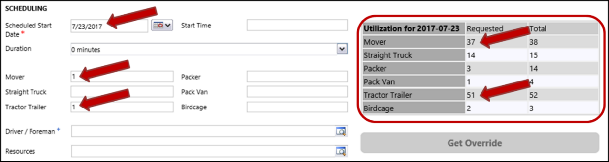

### View a Specific Date’s Current Resource Utilization

View the current resource utilization for a date other than the current Service Activities “Start Date”.

1. Navigate to the desired Service Activity.
   1. The “Service Activity” window will open and display.
2. Scroll down to the “Scheduling” section.
3. Change the “Scheduled Start Date” to the desired date.
   1. **DO NOT SAVE THIS CHANGE, YET.**
   2. The Service Activities requested resource numbers remain entered, just unsaved.
   3. The resources are still allocated for the original “Start Date”.
   4. The values displayed (below) in the current Utilization table do not reflect the unsaved resource numbers for the current Service Activity.

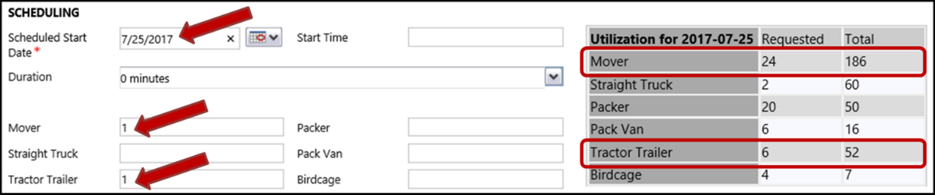

#### Save Resources for New Date

1. Select the “Save” button, to save the Service Activity with the changed “Scheduled Start Date”.
   1. The resources that were allocated for the original “Scheduled Start Date” have been removed and are now no longer allocated on that old date.
   2. The resources are now allocated for the new “Scheduled Start Date”.
   3. The values displayed (below) in the current Utilization table now include the resource numbers for the current (saved) Service Activity.

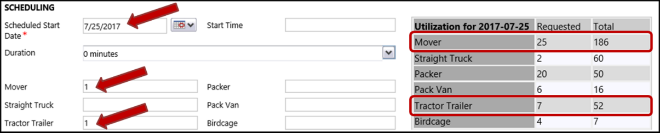

# Utilization Threshold (Move Coordinator)

When a resource’s utilization threshold has been exceeded, the Move Coordinator requesting the resources must get authorization from the Dispatcher. The JIM system will prompt the Move Coordinator for the authorization at the time the resource request is made.

* Resources, being allocated, will require an override when their utilization exceeds 90%.
* Make all your entries or changes to the Service Activity prior to obtaining the override. After obtaining an override, any subsequent changes that create an override will require another override.

## Utilization Reaches Exceeds 90%

1. Navigate to the desired Service Activity.
   1. The “Service Activity” window should be displayed.
2. Enter resource values.
   1. Enter resource values that will bring, at least, one of the resources above the 90% threshold.
   2. Navigate away from the resource field.
3. A message window will display notifying the user that the Utilization Threshold has been exceeded and authorization is required.
   1. **Note:** If you attempt to save the changes, this message window will display and the changes won’t be saved until the authorization is completed by the Dispatcher.
      1. Message: “You have exceeded utilization, you will need an override to save. Please fill all of your resources before getting an override.”
4. Pictured here, the Birdcage, when saved, will require an override.
   1. The Birdcage resource is currently at 50%, this Service Activities newly added Birdcage will cause a 100% utilization.

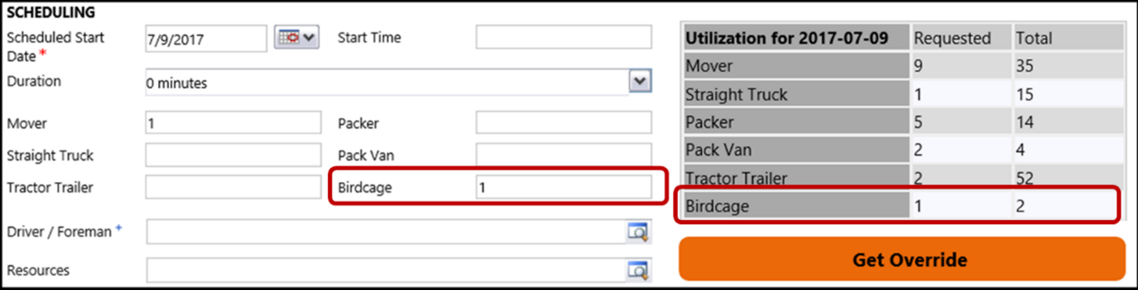

1. The “Get Override” button, just below the current Utilization table, will turn orange and be selectable.
2. Complete all editing of the Service Activity.
3. Contact the appropriate Dispatcher for authorization, when ready to save the changes.
   1. Because the changes require an Override the Dispatcher must perform the authorization and save.
   2. See section [Override Authorization (Dispatcher)](#_Override_Authorization_(Dispatcher)).

## Utilization Reaches or Exceeds 100%

When a resources utilization reaches or exceeds 100%, the resource entry in the utilization display will be highlighted in red.

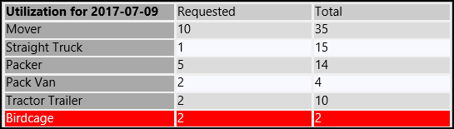

# Minimum Resource Check

When a user creates or updates a Service Activity, a Minimum Resource check is performed, based on “Service Type”, “On/Off Terminal”, “Authority” and “Commodity”.

* The minimum resource check is performed when the Service Activity is saved.
* When Minimum Resources are not met, a “Business Process Error” light box will display. The message in the light box will tell the user what the expected Minimum Resources are.
  + This is an example of the light box that displays when Minimum Resources are not met:

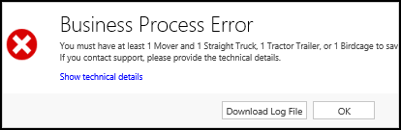

* The Service Activity will not save until the Minimum Resources are met or are exceeded.
  + Note: Any override to the Minimum Resource requirements may be performed later by the Dispatcher on the Local Dispatch Dashboard.

# Resource Blackout Dates (Move Coordinator)

This section explains resource blackout dates and overrides. The Move Coordinator enters the desired resources and when the Scheduled Start Date is blackout, the Dispatcher must authorize an override.

## Scheduled Start Date is on Blackout Date

1. Navigate to the desired Service Activity.
   1. The “Service Activity” window should be displayed.
2. Scroll down to the “Scheduling” section.
3. Change the “Scheduled Start Date” to a date that is blacked out.
4. A message window will display stating what is blacked out for that date.
   1. In this example message both Local and Long Distance are in blackout.

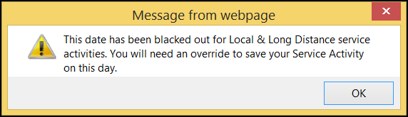

1. Select the OK button.
2. The “Get Override” button, just below the current Utilization table on the Service Activity, will turn orange and be selectable.
3. Complete all editing of the Service Activity.
4. Contact the appropriate Dispatcher for authorization, when ready to save the changes.
   1. Because the changes require an Override the Dispatcher must perform the authorization and save.
   2. See section [Override Authorization (Dispatcher)](#_Override_Authorization_(Dispatcher)).

# Service Activity Creation Application (Move Coordinator)

The Service Activity Creation (SAC) application may create Service Activities requiring an Override Authorization. This could be due to resource overages, not meeting minimum resource requirements and/or scheduling on Blackout dates. When these situations occur,

* The Service Activity may be created with “Needs Override” in the “Status Reason**”** field.
* When the user edits these Service Activities, they may be required to obtain an Override in order to be able to save their changes.
* Although the Move “Status Reason” is “Booked”, the Dispatcher considers these Service Activities not to be “booked” until the Override is obtained.
* Once the override is obtained, the Service Activities “Status Reason” will automatically change to “Pending”.
* Refer to section [Resource Utilization (Move Coordinator)](#_Resource_Utilization_(Move) for Service Activity resource editing and [Override Authorization (Dispatcher)](#_Override_Authorization_(Dispatcher)) obtaining override authorization.

# Override Authorization (Dispatcher)

The Dispatcher must enter the override authorization for the requested resources to be allocated and saved. The Override Authorization is performed by the Dispatcher on the Move Coordinators workstation.

## Authorize the Override

1. Select the orange “Get Override” button.
2. The “Need Override Authorization” light box will display.
3. Enter the override authorization.
   1. **Choose Dispatchers** – Select the Dispatcher’s name.
   2. **Password** – The Dispatcher must enter their password.
4. Select the “Authorize Override” button.

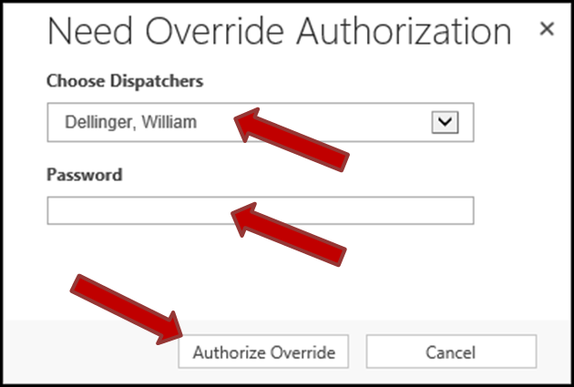

1. The “Need Override Authorization” window will vanish.
   1. The override is now authorized.
2. The changes requiring the override are **not yet** committed.
3. The “Service Activity” page will now be redisplayed.
   1. The “Get Override” button is now greyed out and not selectable.
4. Select the “Save” button to save all changes to the Service Activity.
   1. This step is important, to ensure that no further changes requiring override are made without proper authorization.

# Set Blackout Dates (Dispatcher)

The setting of blackout dates is performed by the Dispatcher.

## Set a Blackout Date

1. Navigate to the Utilization page.
   1. Select Service from the menu.
2. The “Utilization” page will display.
3. Locate the desired Date records.
   1. There are 2 records, one for JK Virginia and the other for JK Maryland.
   2. **NOTE**: Both records must be changed to the same Blackout condition.
4. Perform this step for both JK Virginia and JK Maryland records.
   1. Select the desired record.
      1. The “*Site* Utilization for *xx/xx/xxxx*” page will display.
         1. Where Site represents either JK Virginia or JK Maryland.
         2. Where *xx/xx/xxxx* represents the desired blackout date.
      2. Enter the “Blackout” selection from the dropdown menu.
         1. Options are:
            1. **Blank** – Not blackout
            2. **Local** – Blackout applies only to Local moves.
            3. **Long Distance** – Blackout applies only to Long Distance moves.
            4. **Local & Long Distance** – Blackout applies to both Local and Long Distance.
      3. Select the “Save & Close” button.

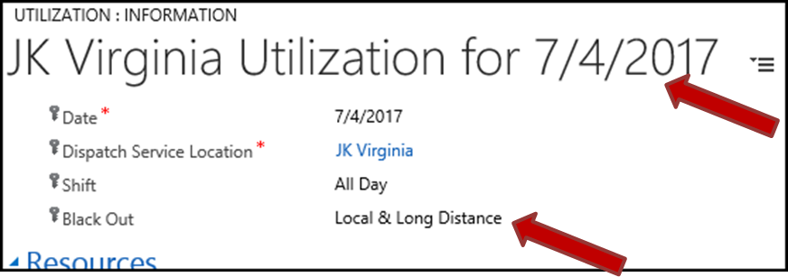

* 1. The “Utilization” page will redisplay.
  2. Repeat step for the other Site.

1. The “Utilization” page will be redisplayed.
   1. **NOTE**: Both Sites now show Blackout for the desired Date.

